TRACKING YOUR WATER USAGE

Download the app My Water Advisor 2.0 on your phone. It looks like a little person on a blue background.
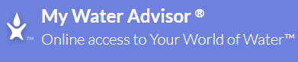
Once you have it downloaded you will need your customer number. Do not use a phone number as our system is not set up that way.
Create your login information, email and password. This information should be the same for you and your spouse if you both download the app.
The front page will look similar to this:
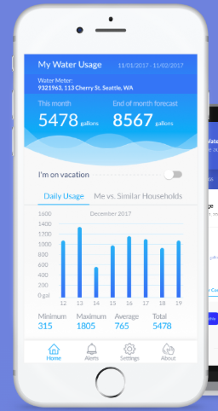
In this app you will be able to set alerts for
“Above Maximum Consumption”
“Leak”
“Consumption During Vacation”
“Monthly Consumption”

To set your Maximum usage, go to “Billing Cycle Limit”. There will be a box to enter the amount, then click set. You sill see it on the front screen at the top.
Then go to settings and turn on all the alerts you want to get by email or text. Remember, the number gallons you put into you billing cycle limit, that’s what the alert goes on.
You can set the app when you go on vacation. This does not turn your water off, this will tell you if water is being used while you’re gone.
You can track your hourly, daily or monthly usage.
If you have an alert it will not show up with an indication. You will have to check it.

We do understand this can be confusing to some. If you have any questions in setting anything up, please come by and ask. We will help you get everything set up, so you are able to start tracking your water usage. Please remember, you cannot turn your water off with the app, this is just a tracking device.

