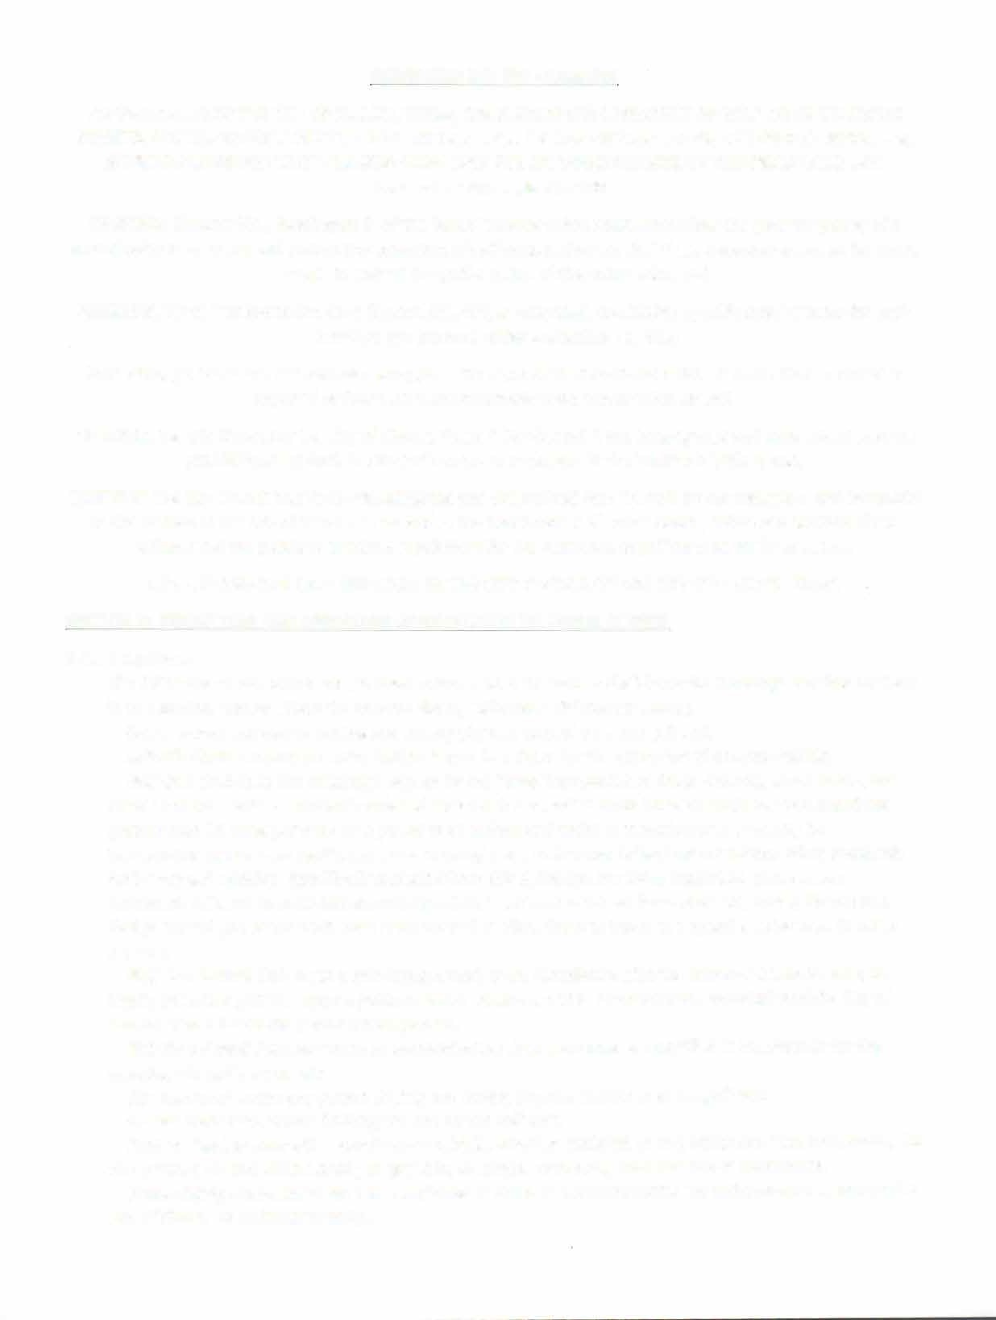
ORDINANCE NO. 386 - Amended
AN ORDINANCE OF THE CITY OF CLAUDE, TEXAS, REGULATING THE OPERATION OF GOLF CARTS ON PUBLIC STREETS; PROVIDING FOR A PENALTY FOR THE VIOLATION OF THIS ORDINANCE; PROVIDING FOR REPEALING, SAVINGS AND SEVERABILITY CLAUSES; PROVIDING FOR AN EFFECTIVE DATE OF THIS ORDINANCE; AND PROVIDING FOR PUBLICATION.
WHEREAS, Chapter 551, Subchapter F, of the Texas Transportation Code, authorizes the governing body of a municipality to regulate and control the operation of golf carts within the city's legal boundaries and on its public streets to ensure the public safety of the community; and
WHEREAS, Texas Transportation Code Section 551.404, as amended, establishes specific requirements for each municipal government under subsection (a); and,
WHEREAS, golf carts are not normally equipped with many of the traditional safety features that customarily required or found on more commonly used motor vehicles; and,
WHEREAS, the City Council of the City of Claude, Texas ("City Council") has investigated and determined that the prohibitions set forth in this Ordinance are necessary in the interest of safety; and,
WHEREAS, the City Council has further investigated and determined that it would be advantageous and beneficial to the citizens of the City of Claude, Texas and in the best interest of public health, safety and welfare of the citizens and the public to establish regulations for the operation of golf carts as set forth below.

NOW, THEREFORE, BE IT ORDAINED BY THE CITY COUNCIL OF THE CITY OF CLAUDE, TEXAS: SECTION 1: PERMITTING AND OPERATION OF GOLF CARTS ON PUBLIC STREETS
  - Definitions
The following words, terms, and phrases, when used in this article shall have the meanings ascribed to them in this section, except where the context clearly indicates a different meaning:
Driver means the person driving and having physical control over the golf cart.
Driver's License means an authorization issued by a State for the operation of a motor vehicle.
Golf Cart shall have the meaning assigned by the Texas Transportation Code 502.001, as amended, and means a motor vehicle commonly referred toas a golf cart, which must have an attainable top speed not greater than 25 miles per hour on a paved level surface and which is manufactured primarily for transporting persons on a golf course and in compliance with those federal motor vehicle safety standards for low-speed vehicles. Specifically excluded from this definition are those motorized conveyances commonly referred to as all-terrain vehicles (ATVs"), off road vehicles, four-wheelers, Mules, Gators and design altered golf carts which have been altered to allow them to travel at a speed greater than 25 miles per hour.
Golf Cart Permit shall mean a privilege granted, upon compliance with the terms of this ordinance, to legally operate a golf cart upon a public street or roadway within the corporate boundaries of the City of Claude, Texas during the period when granted.
Golf Cart Permit Fee shall mean an administrative charge imposed as specified in the chapter for the granting of a golf cart permit.
Operator shall mean any person driving and having physical control over the golf cart.
Owner means the person holding the title to the golf cart.
Park or Parking means the standing of a vehicle, whether occupied or not, otherwise than temporarily for the purpose of, and while actually engaged in, loading or unloading merchandise or passengers.
Public Safety Personnel means any employee or office of a governmental law enforcement agency or the City of Claude or its Department(s).

Public Street means the public roadways of the City of Claude by whatever name, e.g. road, alley, avenue, highway, route, boulevard, etc. within the corporate boundaries of Claude that:
    - Has a speed limit of 30 miles per hour or less;
    - Provides for no more than one lane of vehicular traffic per direction;
    - Is not designated as part of either the State or Federal highway system.
Texas Transportation Code means the code as it currently exists or may be amended.

Permit Required
    - No golf cart shall operate on any authorized public streets, parking areas and traffic ways unless a valid permit has been issued for the golf cart or otherwise allowed by law.
    - Application for a permit authorizing the operation of a golf cart shall be made by a person who owns, leases or otherwise uses a golf cart. Such application shall be made in writing to the City of Claude on a form designated for that purpose. On such application shall be set forth the following:
      - The name, address, telephone number, and state driver's license number, if applicable, of the permit holder;
      - The street address where the golf cart is kept, including the particular suite or apartment number, if applicable;
      - The year, make, model, color, vehicle identification number or serial number if no vehicle identification number has been issued to the golf cart; and
      - License Plate Number now required by the State of Texas in House Bill 1548.
      - Statement that all operators will comply with the guidelines and requirements listed in this Ordinance; and
      - Statement that the permit holder and any user shall indemnify and hold harmless the City of Claude, Texas for any and all civil liability associated with said permit waives any and all rights to sue or allow subrogation by insurance company;
      - Other information which the City may require.
      - No permit will be issued unless all of the above criteria is met.

    - The applicant for the permit must attest that:
l. The golf cart must be equipped with the following equipment, which must continuously remain in good working and operational order:
- Two (2) headlamps;
- Two (2) tail lamps:
- Side reflectors (two (2) which are amber in color on the front, and two (2) which are red in color for the rear;
- Parking Brake
- Rearview Mirror
    - The permit decal shall be permanently affixed on the left side of the golf cart in such a manner that it is clearly visible. The permit must not be damaged, altered, obstructed or otherwise made illegible. The permit holder shall apply for replacement permit and pay all applicable costs associated with the issuance of a new permit for the golf cart;
    - The permit shall only be placed upon the golf cart for which it was issued;

    - A permit issued to a golf cart shall become invalid if the golf cart is altered in a manner that fails to comply with any requirement of this Ordinance;
    - Permits are valid for a period of one (1} year and each shall expire on December 31st of each year. The following fee(s} shall apply:
l. Permit - $10.00 (includes Permit and Decal}

- Replacement for Lost/Stolen/Damaged - $5.00
- Governmental entities applying for a Registration Permit are exempt from any fees.
    - The permit holder shall notify the City within ten (10} working days if the golf cart transfers ownership. The information shall be submitted on a form designated by the City;
    - Any person who operates a golf cart and fails to receive and properly display a City Permit/Decal will be subject to all applicable state laws, in addition to be in violation of this Ordinance;
    - A permit may be revoked at any time by the City, or its designee(s}, if:
l. There is any evidence that the permit holder cannot safely operate a golf cart or due to multiple violations.
2. The owner or driver fails to abide by the rules and regulations of this ordinance.
    - The commission of any of the violations described herein constitutes evidence that the permit holder cannot safely operate a golf cart on the street within the City of Claude.
I. The permit is not transferable. Upon transfer of ownership of the golf cart to a person who intends to operate it over authorized streets and parking areas, the new owner must permit the golf cart and pay the permit fee as outlined hereinabove.

Liability
Nothing in this Article shall be construed as an assumption of liability by the City of Claude for any injuries (including death} to persons, pet or property which may result from the operation of a golf cart by any driver; and
Owners are fully liable and accountable for the action of any individual that operates and drives said golf cart, both on personal and/or any authorized public streets, parking areas, and traffic ways. This described liability responsibility especially applies to person injuries (including death} or property damage resulting from golf cart drivers who are minors under the age of twenty-one (21} with or without a current and valid driver's license.

Golf Cart Operation
A person, other than Public Safety Personnel, may operate a golf cart on a public street, parking area, and or traffic way if the person obtains a golf cart permit, and meets the following requirements:
    - The maximum speed limit on the public street is thirty (30) miles per hour or less;

    - The driver/operator of a golf cart must meet the following requirements:
      - Must be 10 years old with a parent or legal guardian in the cart, seated next to the driver, who has ability to take control of the golf cart.
      - Operation of a golf cart may occur by any person with a valid Texas permit or drivers license without a parent or legal guardian in the cart, so long as the operator has the capability and responsibility to operate it in a safe manner.
      - The operator must comply with all applicable federal, state, and local laws and ordinances;
      - While the golf cart is in motion, the driver and every passenger in a golf cart must remain seated in a seat designed to hold passengers or be securely held in the lap of a passenger that

is 18 years of age or older. No person may stand or ride in the cargo area of a golf cart while it is moving.
      - The equipment described herein meets the Texas Transportation Code Standards for Golf Carts as they exist or may be amended; and
      - Except for Public Safety Personnel, golf carts shall not be operated on any sidewalk, pedestrian walkway, jogging path, park trail, or any location normally used for pedestrian traffic;
      - Operators of golf carts must not prohibit the flow of traffic and must yield right of way to regular traffic.
      - Drivers are prohibited from traveling on a state highway (287, 207, FM 1151), except to cross at an intersection.
  - Other Uses

Public Safety Personnel may operate a golf cart on any public street, parking area and traffic way without any further restrictions when the golf cart is used in the performance of his/her duties or on official business of the City or on City owned property and City leased properties, including but not limited to, a parade, a festival or other special event.
Provisions may be made for temporary permits for outside persons or agencies to temporarily use golf carts on public streets for parades, special events, or other extenuating circumstances. Allowance for temporary permits must be provided for and authorized by the mayor and his/her designee.
SECTION 2. PENALTY PROVISION

  - Penalties

Any person, firm, entity, or corporation who violates any provision of this Ordinance, as it exists or may be amended, shall be deemed guilty of a misdemeanor, and upon conviction thereof, shall be fine a sum not exceeding Two Hundred Fifty Dollars ($250.00). Each continuing day(s) violation under this Ordinance shall constitute a separate offense. The penal provisions imposed under this Ordinance shall not preclude the City of Claude from filing suit to enjoin the violation. Claude retains all legal rights and remedies available to pursuant to local, state, and federal law.
  - Additional Penalties

In addition to the misdemeanor for traffic violations of the driver of the golf cart may be subject pursuant to Texas Law, the owner and/or permit holder of the golf cart shall be subject to the following civil penalties:
    - For the first offense, a fine of not less than $25.00;
    - For the second and any subsequent offense, a fine of not less than $50.00.

SECTION 3 Savings/Repealing Clause

All provisions of any ordinance in conflict with this Ordinance are hereby repealed to the extent they are in conflict; but such repeal shall not abate any pending prosecution for violation of the repealed ordinance, nor shall the repeal prevent a prosecution from being commenced for any violation of occurring prior to the repeal of the ordinance. Any remaining portions of said ordinances shall remain in full force and effect.
SECTION 4 SEVERABILITY
Should any section, subsection, clause, or phrase of this ordinance be declared unconstitutional or invalid by any court of competent jurisdiction, it is expressly provided that any and all remaining portions of this Ordinance shall remain in full force and effect.

SECTION 5 Effective Date

This Ordinance shall be effective December 31, 2020 and publication as required by law.

AMENDED AND APPROVED THIS THE 8th DAY OF DECEMBER, 2025

BY
The City Council of Claude, Texas

_________________________________
ATTEST: Mayor, City of Claude

______________________________
City Secretary, City of Claude

